How to Create a Tejas Punchout Requisiton:

**Prior to creating your order, you should have been provided with a quote from IT. If you do not have a quote, contact IT services to request one.**

- Under the Procurement tab, click Purchase Requisitions:

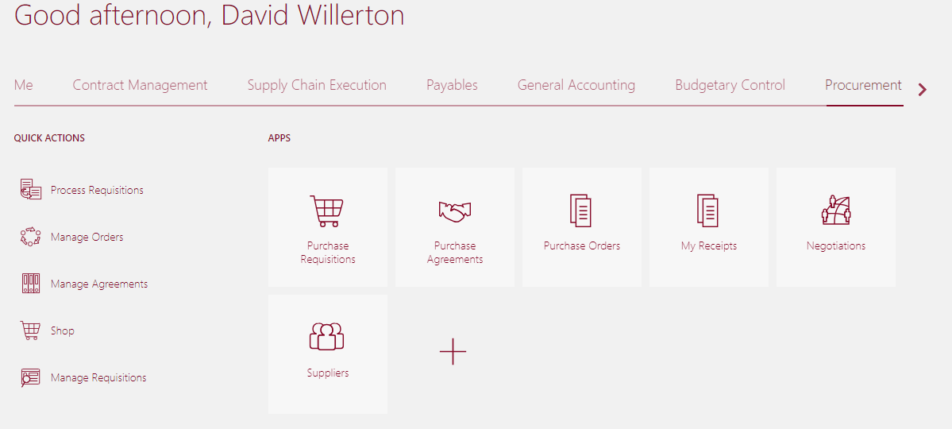

- Click the Tejas Office Products link:
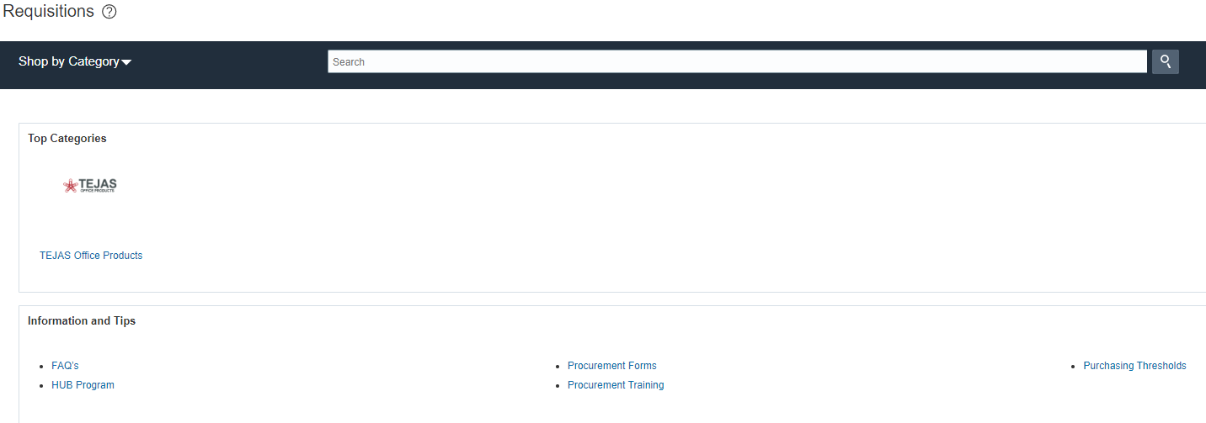

- Navigate to the desired item(s) using the categories on the welcome page. Example: If you want to purchase a laptop, click on FS Laptops.

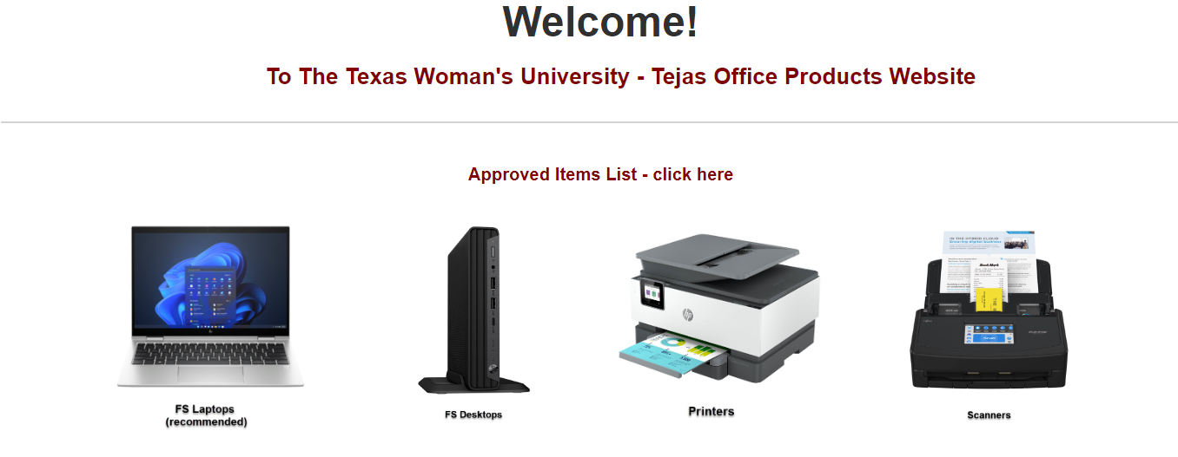

- Select items to add to cart by clicking red button on right of each item:

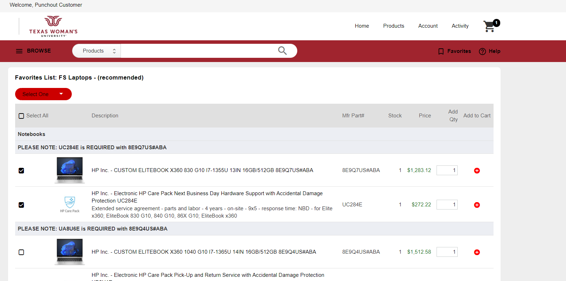

- When you are finished adding items, click the cart icon in the upper right corner to review your order.
- Enter a description for the order as well as any additional email addresses to receive notifications regarding this order:
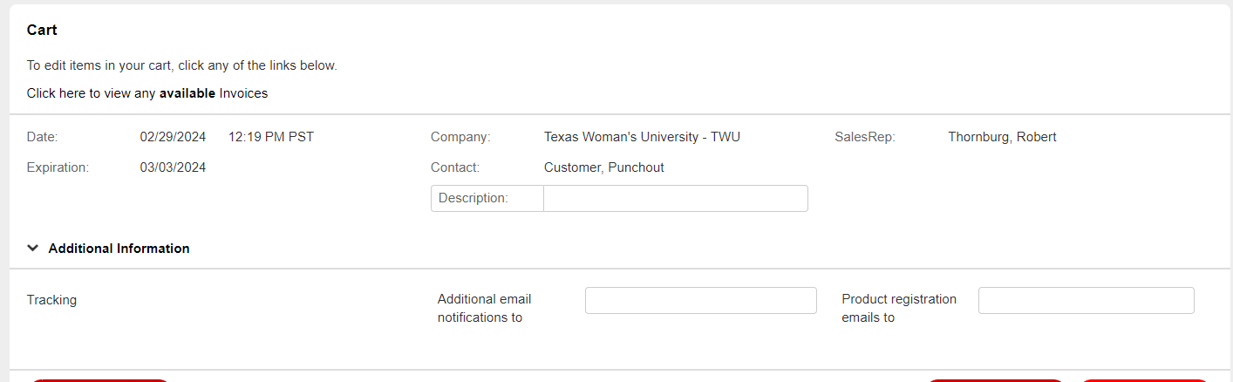

- Add quote number under document notes. Click Checkout:
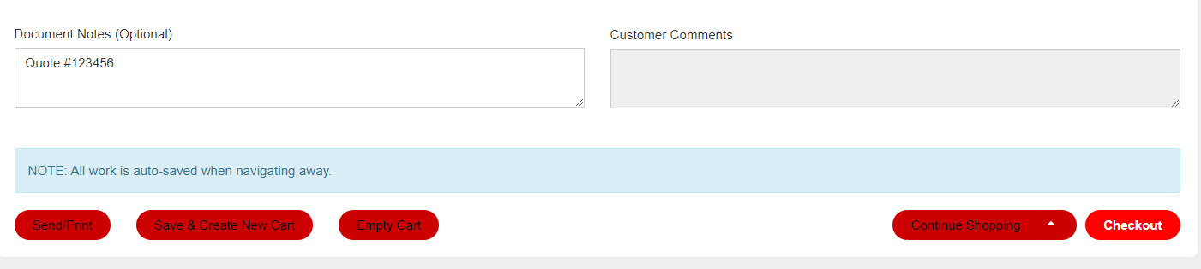

- Requisition will be created and website will re-direct back to Cloud. Update the order description, and add any attachments needed (In attachments window, make sure to select the category drop down arrow “To Buyer”. You can change ‘Title’ or leave it as is. Leave ‘Description’ blank. Click OK.): 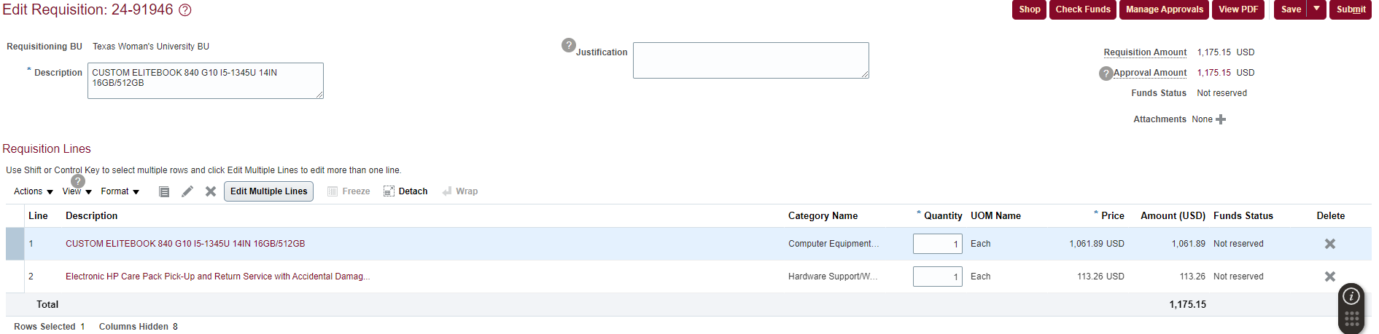

- Click Save, click Submit.

