How to Create a Non-Catalog Requisition:

- Under the Procurement tab. Click on Purchase Requisitions:

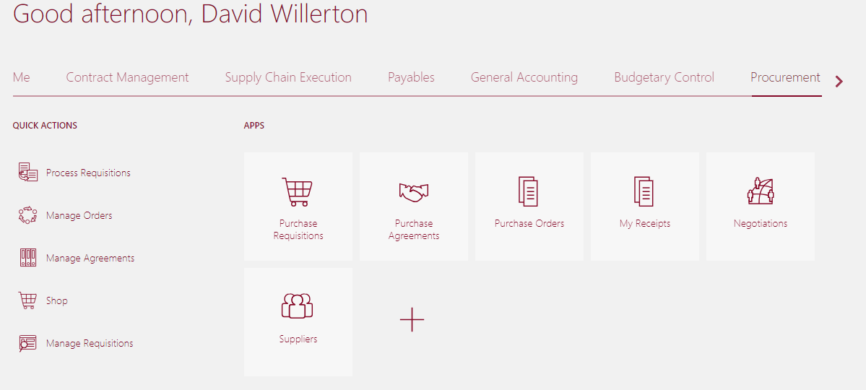

- From More Tasks drop down, select Request Noncatalog Item:
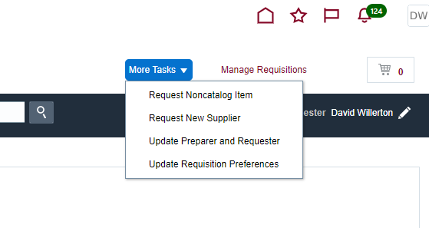

- Confirm that you do not have any other items in your cart other than what you wish to add to the requisition.
- Fill in information on all required fields with an asterisk.
- Also select Item Type as well as Supplier – Item Type should only be either Goods or Services billed by Quantity.
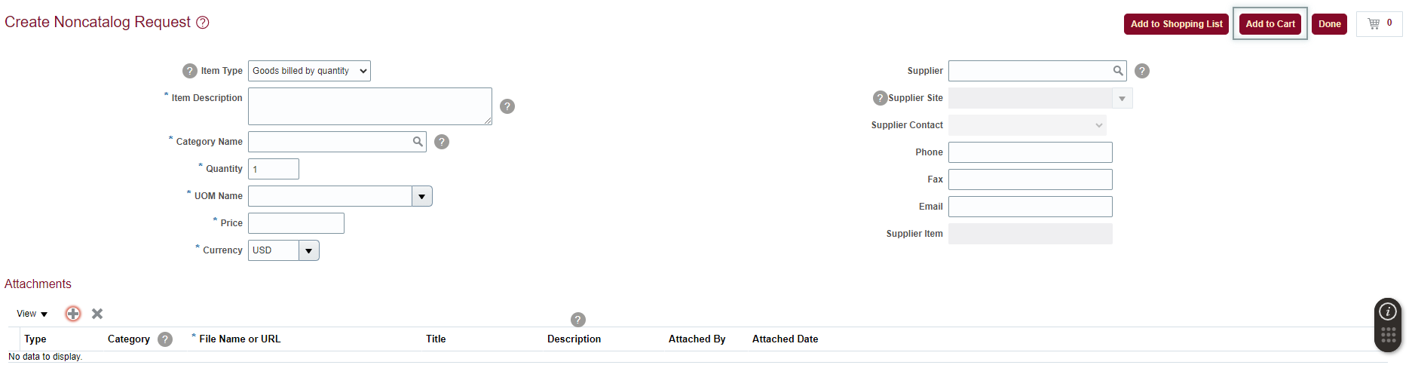

If desired supplier cannot be found, check new supplier box and contact TWUSupplier@twu.edu to assist in setting up vendor.
When complete, click Add to Cart and then click on the to review your order.
(Note-clicking Done will cause you to lose any information not already saved to cart)

- Click Cart icon and choose Review to navigate to next page.
- Add any attachments (quote, risk assessment, etc.) to your header section.
- In Category drop down, select To Buyer for all attachments and change Title to reflect document type.
- Leave Description blank:
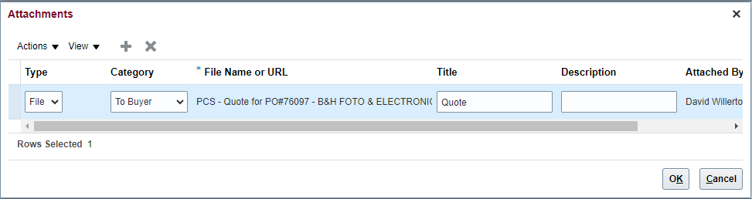

- Scroll down to line details and review Charge Account to confirm the charge account details and natural account (object code) are correct.
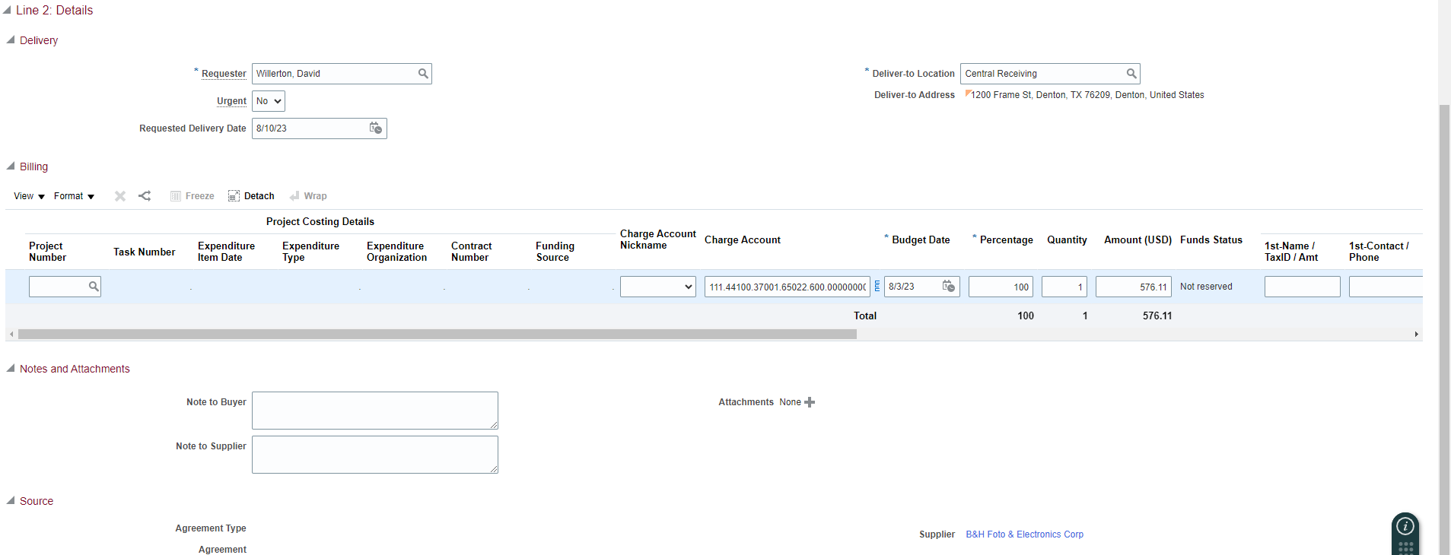

- Return to top of page, Save > Submit:
