How to Correct a Requisition in Cloud

- Under the Procurement tab, click on the Purchase Requisitions icon:
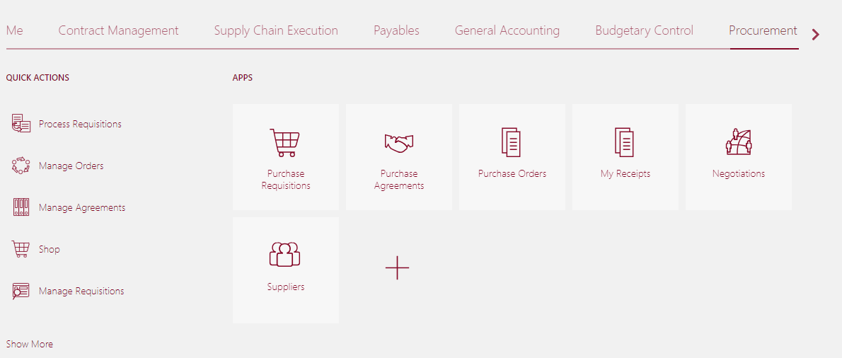

- Select Manage Requisitions near the top of the page:

- Enter information into at least ONE of the required fields (Entered by, Requisition number, Supplier or Order #). Click Search:

- Click on the requisition number to open the requisition:

- From the Actions drop down menu, select ‘Edit’:
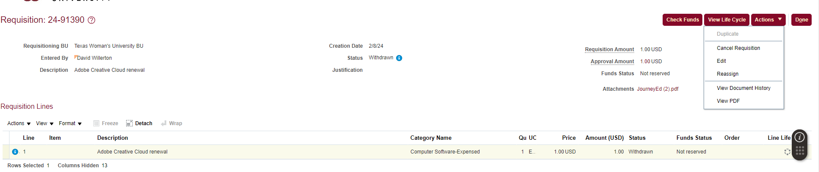

- In the Requisition Lines area, click on the line you want to correct to highlight it. Once the line is blue, click the pencil icon above the line:
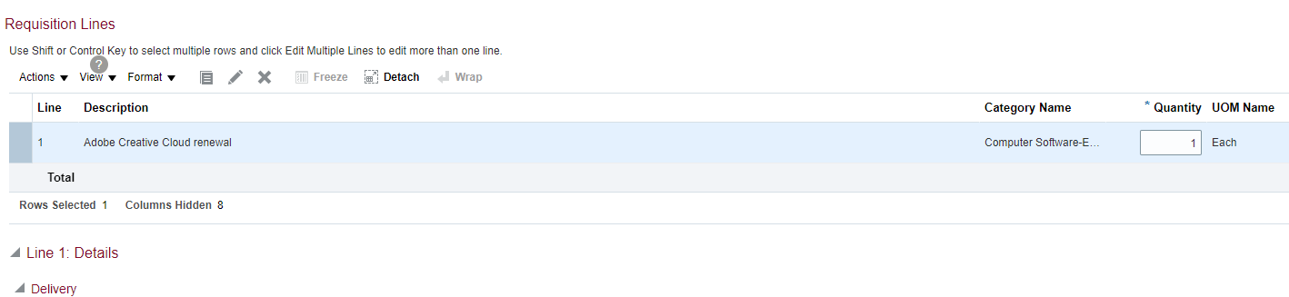

- The Edit box will appear. This is where you can change the information about your selected line, including Category Name (note: changing the Category Name will automatically change the Natural Account number. Changing the number alone will not work.)
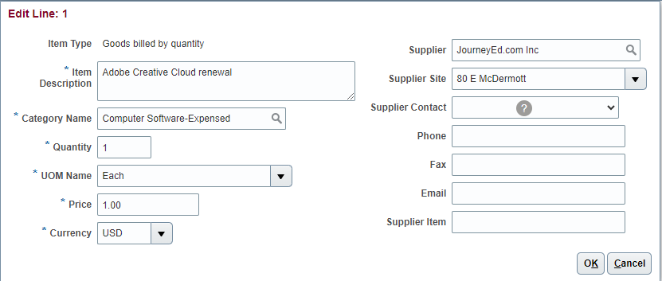

- Click OK to leave Edit screen. Then click Submit.
